Creating an IMAGE:

At the HEADER, property SLUG, please send always the equipment number concatenated with the filename and separated by ‘_’. Example:

**200518731**_lion.jpg

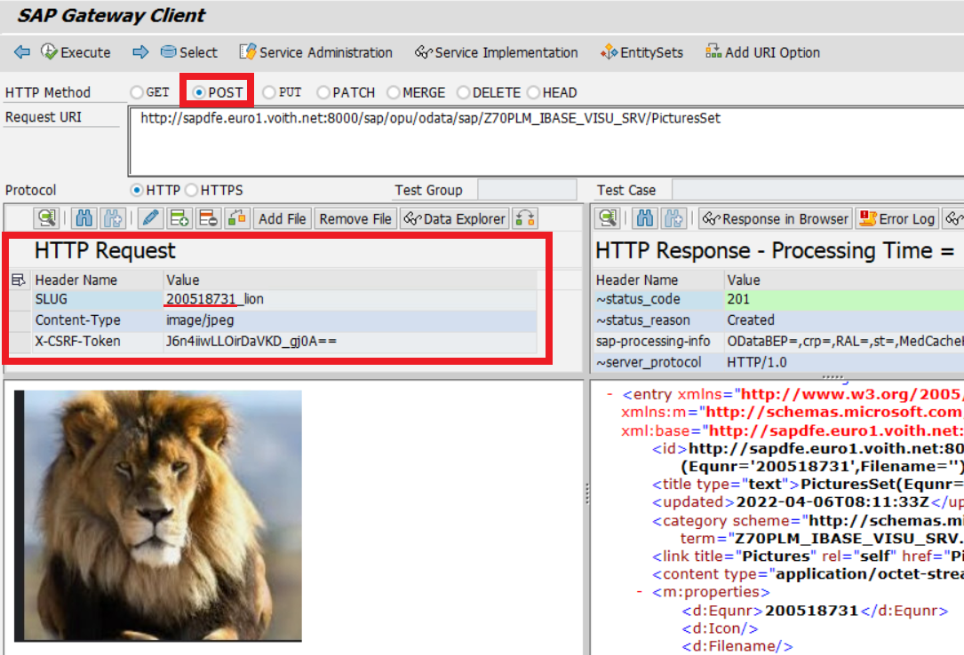

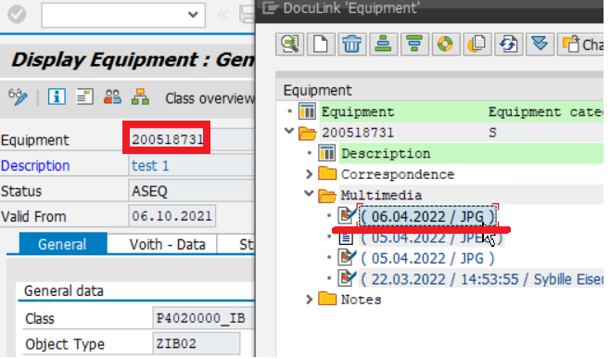

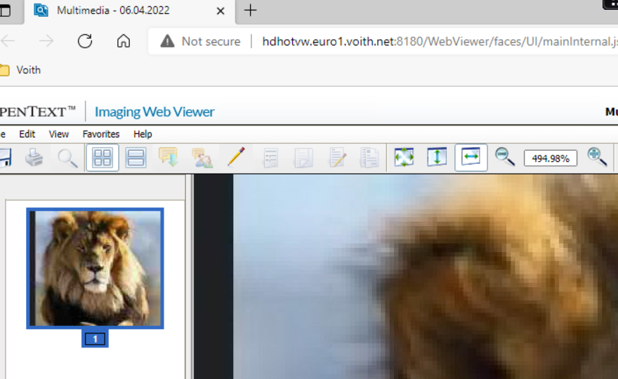

Get Files:

http://sapdfe.euro1.voith.net:8000/sap/opu/odata/sap/Z70PLM_IBASE_VISU_SRV/PicturesSet?$filter=Equnr eq '200518731'&$format=json

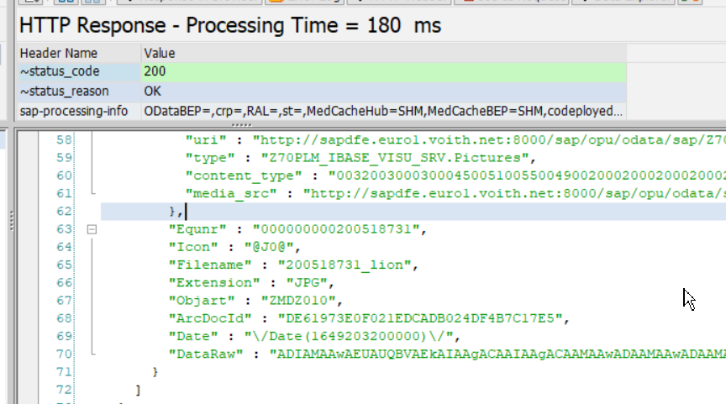

Get Specific Image:

<http://sapdfe.euro1.voith.net:8000/sap/opu/odata/sap/Z70PLM_IBASE_VISU_SRV/PicturesSet(Equnr='200518731',Filename='200518731_lion')/$value>

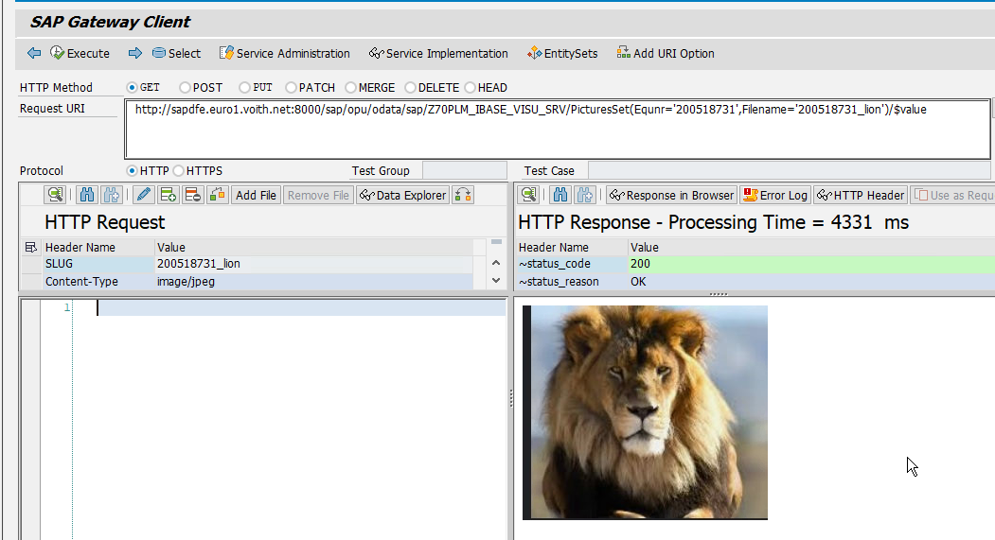

MEDIA API:

METHOD /iwbep/if_mgw_appl_srv_runtime~create_stream.  
  
 DATA: o_ref TYPE REF TO data,  
 lv_equi TYPE zcl70plm_ibase_visu_mpc=>ts_pictures-equnr,  
 lv_msgty TYPE symsgty,  
 lv_msgid TYPE symsgid,  
 lv_msgno TYPE symsgno.  
 *"Get RFC destination*  
 DATA(lo_dp_facade) = /iwbep/if_mgw_conv_srv_runtime~get_dp_facade( ).  
 DATA(lv_destination) = /iwbep/cl_sb_gen_dpc_rt_util=>get_rfc_destination( io_dp_facade = lo_dp_facade ).  
  
 CHECK lv_destination IS NOT INITIAL AND lv_destination NE 'NONE'.  
  
 FIND FIRST OCCURRENCE OF '_' IN iv_slug MATCH OFFSET DATA(lv_offset).  
  
 lv_equi = |{ iv_slug(lv_offset) ALPHA = IN }|.  
  
 CALL FUNCTION 'Z_20PLM_IBASE_VISU_CREATE_PIC' DESTINATION lv_destination  
 EXPORTING  
 iv_equi = lv_equi  
 iv_filename = iv_slug  
 iv_mimetype = is_media_resource-mime_type  
 iv_value = is_media_resource-value  
 EXCEPTIONS  
 wrong_extension = 1  
 nothing_found = 2  
 binary_tab = 3  
 error_archiv = 4  
 error_communicationtable = 5  
 error_kernel = 6  
 error_connectiontable = 7  
 system_failure = 1000  
 OTHERS = 1002.  
  
 IF sy-subrc = 0.  
  
 CREATE DATA o_ref TYPE zcl70plm_ibase_visu_mpc=>ts_pictures.  
  
 ASSIGN o_ref->* TO FIELD-SYMBOL(<fs_oref>).  
 CHECK <fs_oref> IS ASSIGNED.  
 ASSIGN COMPONENT 'EQUNR' OF STRUCTURE <fs_oref> TO FIELD-SYMBOL(<fs_data>).  
 IF <fs_data> IS ASSIGNED.  
 <fs_data> = lv_equi.  
 ENDIF.  
  
 ASSIGN COMPONENT 'DATE' OF STRUCTURE <fs_oref> TO <fs_data>.  
 IF <fs_data> IS ASSIGNED.  
 <fs_data> = sy-datum.  
 ENDIF.  
  
 ASSIGN COMPONENT 'FILENAME' OF STRUCTURE <fs_oref> TO <fs_data>.  
 IF <fs_data> IS ASSIGNED.  
 <fs_data> = iv_slug.  
 ENDIF.  
  
 er_entity = o_ref.  
  
 ELSE.  
  
 lv_msgty = 'E'.  
 lv_msgid = 'Z20PLM_IBASE_VISU'.  
  
 CASE sy-subrc.  
 WHEN 1.  
 lv_msgno = 002. *"Error during uploading*  
 WHEN OTHERS.  
 lv_msgno = 001. *"Unacceptable extension*  
 ENDCASE.  
  
 mo_context->get_message_container( )->add_message(  
 EXPORTING  
 iv_msg_type = lv_msgty *" Message Type*  
 iv_msg_id = lv_msgid *" Message Class*  
 iv_msg_number = lv_msgno *" Message Number*  
 ).  
  
 RAISE EXCEPTION TYPE /iwbep/cx_mgw_busi_exception  
 EXPORTING  
 message_container = mo_context->get_message_container( ).  
  
 ENDIF.  
  
ENDMETHOD.

METHOD /iwbep/if_mgw_appl_srv_runtime~get_stream.  
  
 DATA : ls_stream TYPE ty_s_media_resource,  
 lt_files TYPE TABLE OF z70plms_ibase_visu_files_s,  
 lv_equnr TYPE c LENGTH 18,  
 lv_filename TYPE string.  
  
 READ TABLE it_key_tab ASSIGNING FIELD-SYMBOL(<fs_key>) WITH KEY name = 'Equnr'.  
 CHECK sy-subrc = 0.  
  
 lv_equnr = <fs_key>-value.  
 READ TABLE it_key_tab ASSIGNING <fs_key> WITH KEY name = 'Filename'.  
 CHECK sy-subrc = 0.  
  
 lv_filename = <fs_key>-value.  
 *"Get RFC destination*  
 DATA(lo_dp_facade) = /iwbep/if_mgw_conv_srv_runtime~get_dp_facade( ).  
 DATA(lv_destination) = /iwbep/cl_sb_gen_dpc_rt_util=>get_rfc_destination( io_dp_facade = lo_dp_facade ).  
  
 CHECK lv_destination IS NOT INITIAL AND lv_destination NE 'NONE'.  
  
 CALL FUNCTION 'Z_20PLM_IBASE_VISU_PICTURES' DESTINATION lv_destination  
 EXPORTING  
 iv_equnr = lv_equnr  
 IMPORTING  
 et_files = lt_files  
 EXCEPTIONS  
 system_failure = 1000  
 OTHERS = 1002.  
  
 CHECK sy-subrc = 0.  
  
 READ TABLE lt_files ASSIGNING FIELD-SYMBOL(<fs_file>) WITH KEY filename = lv_filename.  
 CHECK sy-subrc = 0.  
  
 ls_stream-value = <fs_file>-data_raw.  
  
 CASE <fs_file>-extension.  
 WHEN 'BMP'.  
 ls_stream-mime_type = 'image/bmp'.  
 WHEN 'PNG'.  
 ls_stream-mime_type = 'image/png'.  
 WHEN 'JPG'.  
 ls_stream-mime_type = 'image/jpeg'.  
 WHEN 'JPEG'.  
 ls_stream-mime_type = 'image/jpeg'.  
 WHEN 'HEIC'.  
 ls_stream-mime_type = 'image/heic'.  
 WHEN OTHERS.  
 ENDCASE.  
  
 copy_data_to_ref( EXPORTING is_data = ls_stream CHANGING cr_data = er_stream ).  
  
ENDMETHOD.

FUNCTION z_20plm_ibase_visu_create_pic.  
*\*"----------------------------------------------------------------------*  
*\*"*"Local Interface:*  
*\*" IMPORTING*  
*\*" VALUE(IV_EQUI) TYPE EQUNR*  
*\*" VALUE(IV_FILENAME) TYPE STRING*  
*\*" VALUE(IV_MIMETYPE) TYPE STRING*  
*\*" VALUE(IV_VALUE) TYPE XSTRING*  
*\*" EXCEPTIONS*  
*\*" WRONG_EXTENSION*  
*\*" NOTHING_FOUND*  
*\*" BINARY_TAB*  
*\*" ERROR_ARCHIV*  
*\*" ERROR_COMMUNICATIONTABLE*  
*\*" ERROR_KERNEL*  
*\*" ERROR_CONNECTIONTABLE*  
*\*"----------------------------------------------------------------------*  
*\*---------------------------------------------------------------------*  
*\* Function module: Z_20PLM_IBASE_VISU_CREATE_PIC*  
*\* Title: Save Picture related to equipment*  
*\* Autor: Igor Muntoreanu*  
*\* Customer: Oliver Baunholzer DSG*  
*\* Created: 2022-04*  
*\**  
*\* Short description: Save Picture related to equipment*  
*\*---------------------------------------------------------------------*  
*\* Changes: Description (newest on top)*  
*\*---------------------------------------------------------------------*  
*\* LNr / JJJJ-MM-TT / Name / Project-Nr*  
*\*---------------------------------------------------------------------*  
  
 DATA: gv_equi TYPE equnr,  
 gv_len TYPE i,  
 gv_arc_doc_id TYPE saeardoid,  
 gv_archiv_id TYPE saearchivi,  
 gt_content1024 TYPE TABLE OF tbl1024, *"RAW 1024 format*  
 gv_length TYPE sapb-length,  
 gv_objid TYPE sapb-sapobjid,  
 gv_file_name TYPE toaat-filename,  
 gs_j_8a3t0013 TYPE j_8a3t0013.  
  
 SELECT SINGLE *  
 FROM toadd  
 INTO @DATA(ls_toadd)  
 WHERE mimetype = @iv_mimetype.  
 IF sy-subrc <> 0. *"Wrong/Unacceptable extension*  
 RAISE wrong_extension.  
 ENDIF.  
  
 gv_equi = |{ iv_equi ALPHA = IN }|.  
  
 CALL FUNCTION 'ARCHIV_CONNECTDEFINITION_GET'  
 EXPORTING  
 objecttype = 'EQUI'  
 documenttype = 'ZMDZ010'  
 client = sy-mandt  
 IMPORTING  
 archivid = gv_archiv_id  
 EXCEPTIONS  
 nothing_found = 1  
 OTHERS = 2.  
  
 IF sy-subrc <> 0.  
 RAISE nothing_found.  
 ENDIF.  
  
 CALL FUNCTION 'SCMS_XSTRING_TO_BINARY'  
 EXPORTING  
 buffer = iv_value  
 IMPORTING  
 output_length = gv_len  
 TABLES  
 binary_tab = gt_content1024.  
  
 IF gt_content1024 IS INITIAL.  
 RAISE binary_tab.  
 ENDIF.  
  
 gv_length = gv_len.  
  
 CALL FUNCTION 'ARCHIVOBJECT_CREATE_TABLE'  
 EXPORTING  
 archiv_id = gv_archiv_id  
 document_type = ls_toadd-doc_type *"extension*  
 length = gv_length  
 IMPORTING  
 archiv_doc_id = gv_arc_doc_id  
 TABLES  
 binarchivobject = gt_content1024  
 EXCEPTIONS  
 error_archiv = 1  
 error_communicationtable = 2  
 error_kernel = 3  
 OTHERS = 4.  
  
 CASE sy-subrc.  
 WHEN 1.  
 RAISE error_archiv.  
 WHEN 2.  
 RAISE error_communicationtable.  
 WHEN 3.  
 RAISE error_kernel.  
 WHEN OTHERS.  
 ENDCASE.  
  
 gv_file_name = iv_filename.  
 gv_objid = gv_equi.  
 CONDENSE gv_objid.  
  
 CALL FUNCTION 'ARCHIV_CONNECTION_INSERT'  
 EXPORTING  
 archiv_id = gv_archiv_id  
 arc_doc_id = gv_arc_doc_id  
 ar_object = 'ZMDZ010'  
 object_id = gv_objid  
 sap_object = 'EQUI'  
 doc_type = ls_toadd-doc_type *"extension*  
 filename = gv_file_name  
 descr = 'Uploaded from the IBase App'  
 creator = sy-uname  
 EXCEPTIONS  
 error_connectiontable = 1  
 OTHERS = 2.  
  
 IF sy-subrc <> 0.  
 RAISE error_connectiontable.  
 ENDIF.  
  
*\*\* -------------------------------------------------------------*  
*\*\* DocuLink-ODMA-Attribute fortschreiben. /*  
*\*\* Necessary so the values are going to be displayed at the DocuLink Icon in IE03*  
*\*\* -------------------------------------------------------------*  
 gs_j_8a3t0013-archiv_id = gv_archiv_id.  
 gs_j_8a3t0013-arc_doc_id = gv_arc_doc_id.  
 gs_j_8a3t0013-attribute = '%FILENAME_ONLY'.  
 gs_j_8a3t0013-value = gv_file_name.  
 INSERT INTO j_8a3t0013 VALUES gs_j_8a3t0013.  
  
 gs_j_8a3t0013-attribute = '%USERNAME'.  
 gs_j_8a3t0013-value = sy-uname.  
 INSERT INTO j_8a3t0013 VALUES gs_j_8a3t0013.  
  
 gs_j_8a3t0013-attribute = '%ARC_TIME'.  
 gs_j_8a3t0013-value = sy-uzeit.  
 INSERT INTO j_8a3t0013 VALUES gs_j_8a3t0013.  
  
 COMMIT WORK AND WAIT.  
  
ENDFUNCTION.

FUNCTION z_20plm_ibase_visu_pictures.  
*\*"----------------------------------------------------------------------*  
*\*"*"Local Interface:*  
*\*" IMPORTING*  
*\*" VALUE(IV_EQUNR) TYPE EQUNR*  
*\*" EXPORTING*  
*\*" VALUE(ET_FILES) TYPE Z20PLMS_IBASE_VISU_FILES_T*  
*\*"----------------------------------------------------------------------*  
*\*---------------------------------------------------------------------*  
*\* Function module: Z_20PLM_IBASE_VISU_PICTURES*  
*\* Title: Get Pictures related to equipment*  
*\* Autor: Igor Muntoreanu*  
*\* Customer: Oliver Baunholzer DSG*  
*\* Created: 2022-04*  
*\**  
*\* Short description: Get Pictures related to equipment*  
*\*---------------------------------------------------------------------*  
*\* Changes: Description (newest on top)*  
*\*---------------------------------------------------------------------*  
*\* LNr / JJJJ-MM-TT / Name / Project-Nr*  
*\*---------------------------------------------------------------------*  
  
 DATA: lv_equnr TYPE equnr,  
 lr_ext TYPE RANGE OF w3fileext,  
 ls_ext LIKE LINE OF lr_ext.  
  
 DATA: lv_archiv_id TYPE toaar-archiv_id,  
 lv_document_type TYPE toadd-doc_type,  
 lv_archiv_doc_id TYPE sapb-sapadokid,  
 lv_binlength TYPE sapb-length,  
 lv_length TYPE i,  
 lv_file TYPE xstring,  
 lt_binarchivobject TYPE TABLE OF tbl1024.  
  
 DEFINE add_extension.  
 ls_ext-option = 'EQ'.  
 ls_ext-sign = 'I'.  
 ls_ext-low = &1.  
 INSERT ls_ext INTO TABLE lr_ext.  
 END-OF-DEFINITION.  
  
 lv_equnr = |{ iv_equnr ALPHA = IN }|.  
 DATA(lt_docs) = zcl20plm_ibase_visu_helper=>read_arch_documents( iv_equnr = lv_equnr ).  
  
 LOOP AT lt_docs ASSIGNING FIELD-SYMBOL(<fs_docs>).  
  
 lv_archiv_doc_id = <fs_docs>-arc_doc_id.  
  
 CALL FUNCTION 'ARCHIVOBJECT_GET_TABLE'  
 EXPORTING  
 archiv_id = 'H6'  
 document_type = 'ZMDZ010'  
 archiv_doc_id = lv_archiv_doc_id  
 all_components = space  
 signature = space  
 compid = space  
 IMPORTING  
 binlength = lv_binlength  
 TABLES  
 binarchivobject = lt_binarchivobject  
 EXCEPTIONS  
 error_archiv = 1  
 error_communicationtable = 2  
 error_kernel = 3  
 OTHERS = 4.  
 IF sy-subrc EQ 0.  
  
 lv_length = lv_binlength.  
  
 CALL FUNCTION 'SCMS_BINARY_TO_XSTRING'  
 EXPORTING  
 input_length = lv_length  
 IMPORTING  
 buffer = lv_file  
 TABLES  
 binary_tab = lt_binarchivobject  
 EXCEPTIONS  
 failed = 1  
 OTHERS = 2.  
 IF sy-subrc EQ 0.  
 <fs_docs>-data_raw = lv_file.  
 ENDIF.  
 ENDIF.  
 ENDLOOP.  
  
 et_files = CORRESPONDING #( lt_docs ).  
  
 add_extension: 'JPG'.  
 add_extension: 'JPEG'.  
 add_extension: 'PNG'.  
 add_extension: 'BMP'.  
 add_extension: 'GIF'.  
 add_extension: 'TIFF'.  
 add_extension: 'HEIC'.  
  
 DELETE et_files WHERE extension NOT IN lr_ext.  
  
ENDFUNCTION.